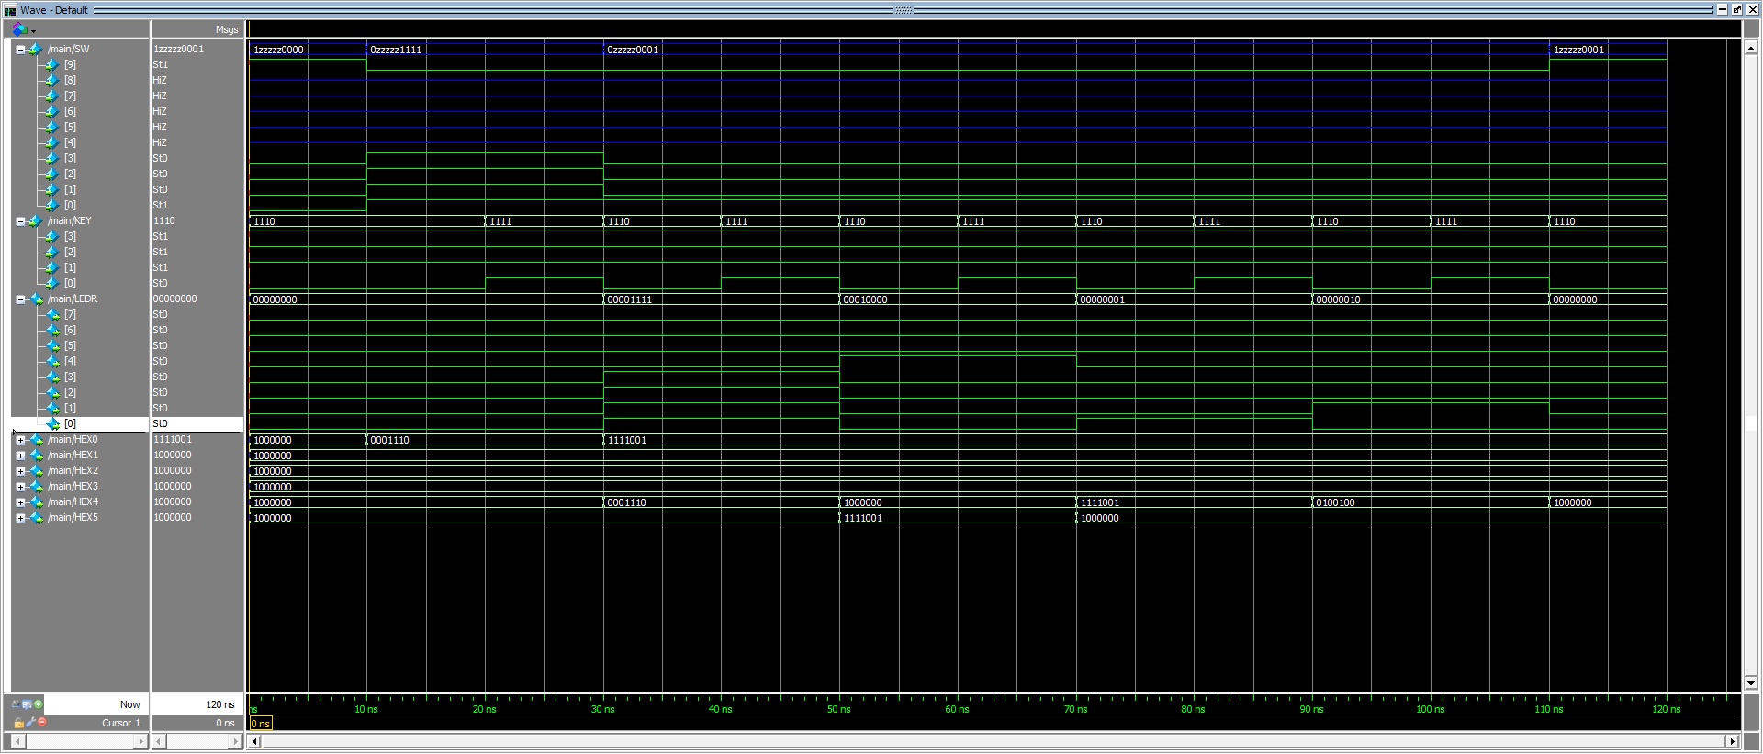

Reset to 0

0001 (A) + 0001 (B) = 0010

Reset B to 0001

0001 (A) + 1111(B) = 10000

1111 (A) + 0000(B) = 1111

Flipped

1->0

0->1

Reset to 0

Values do not change

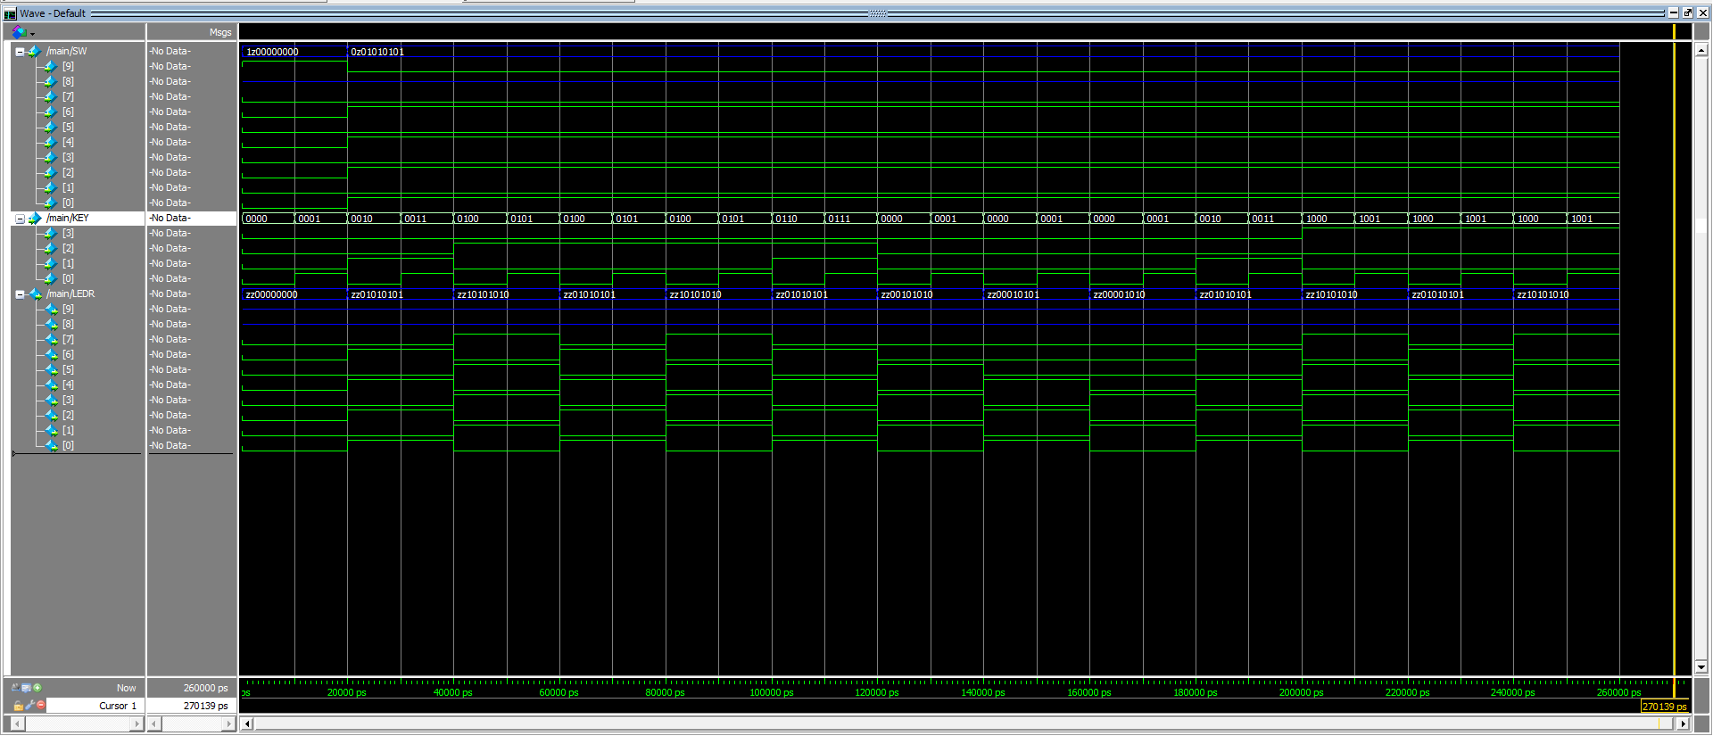

Identical Result to Left Shift due to symmetric pattern, proof of process in:

ASRight = 0, RotateRight = 1, Parallelload = 0

Flipped

1->0

0->1

Right Shift to 10101010

Right Shift to 10101010

Right Shift to 01010101

Set to 01010101

Arithmetic Right Shift to 00001010

Arithmetic Right Shift to 00010101

Arithmetic Right Shift to 00101010

Right Shift to 01010101

Left Shift to 10101010

Left Shift to 01010101

Left Shift to 10101010

Set to 01010101

Reset to 0

Values do not change